Amazon Rekognition

Objectives-
• Use Amazon Rekognition for label detection (identify objects, ature,scenes).
• Perform image property analysis (color,brightness,quality).
• Apply image moderation to detect unsafe or inappropriate content.
• Implement facial analysis (age,emotions,facial features).
• Compare faces using face comparison model.
• Enable face liveness detection for real-time verification.
• Identify famous personalities using celebrity recognition.
• Extract text using text-in-image (OCR).
• Detect safety gear using PPE detection.

---- In AWS Console, search Amazon Rekognition.

Demos-
Label Detection-
Label Detection in Amazon Rekognition is a feature that automatically identifies and classifies objects, scenes, and activities in images or videos. It assigns relevant labels (like sky, cloud, sunset, person, etc.) along with confidence scores, helping in quick and accurate image analysis for automation and decision-making.
Example 1-
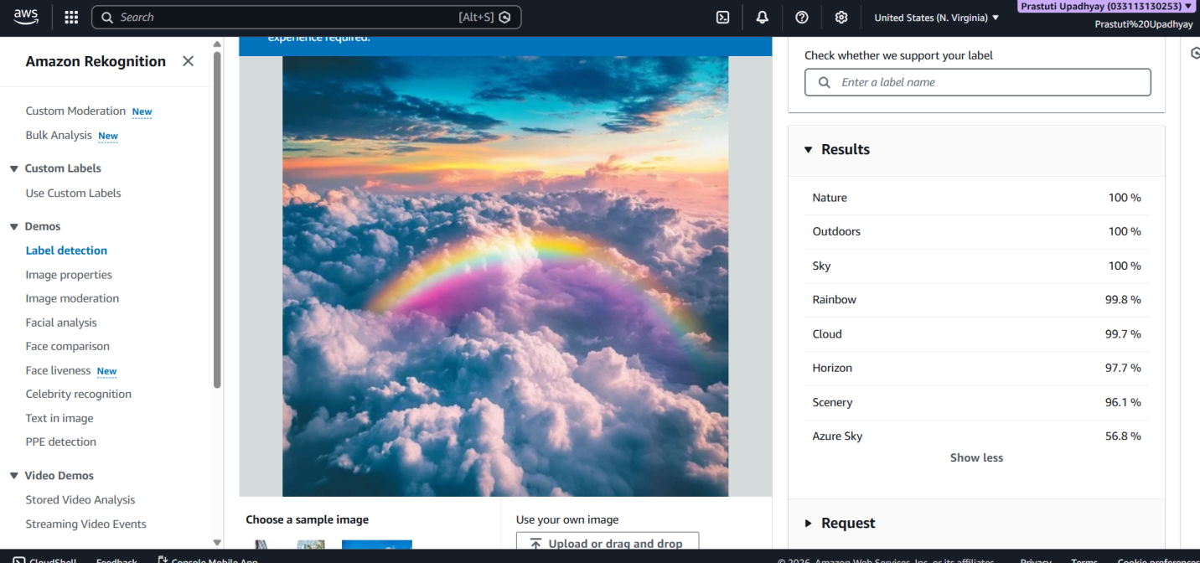
Example 2-
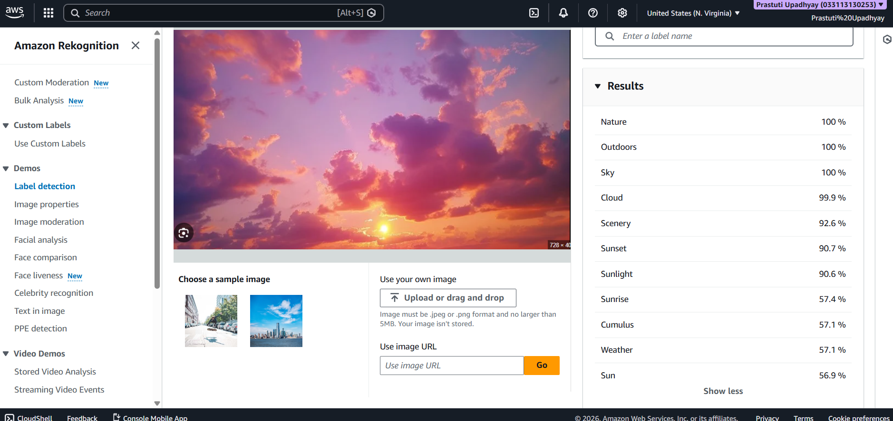
Image Properties-
Image Properties in Amazon Rekognition analyzes the technical details of an image such as color composition, brightness, contrast, sharpness, and quality. It helps evaluate image suitability and improve processing for applications like filtering, enhancement, and quality assessment.
Example 1-
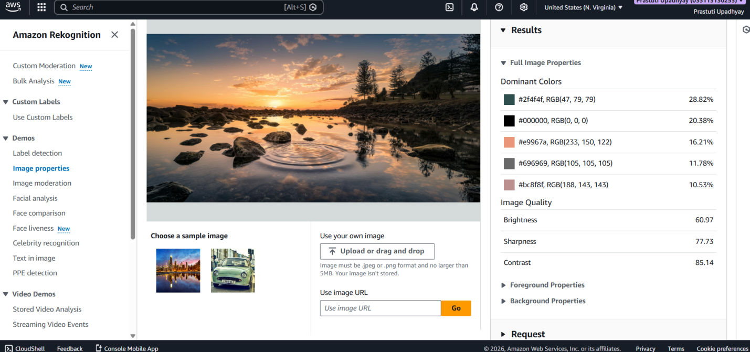
Example 2-
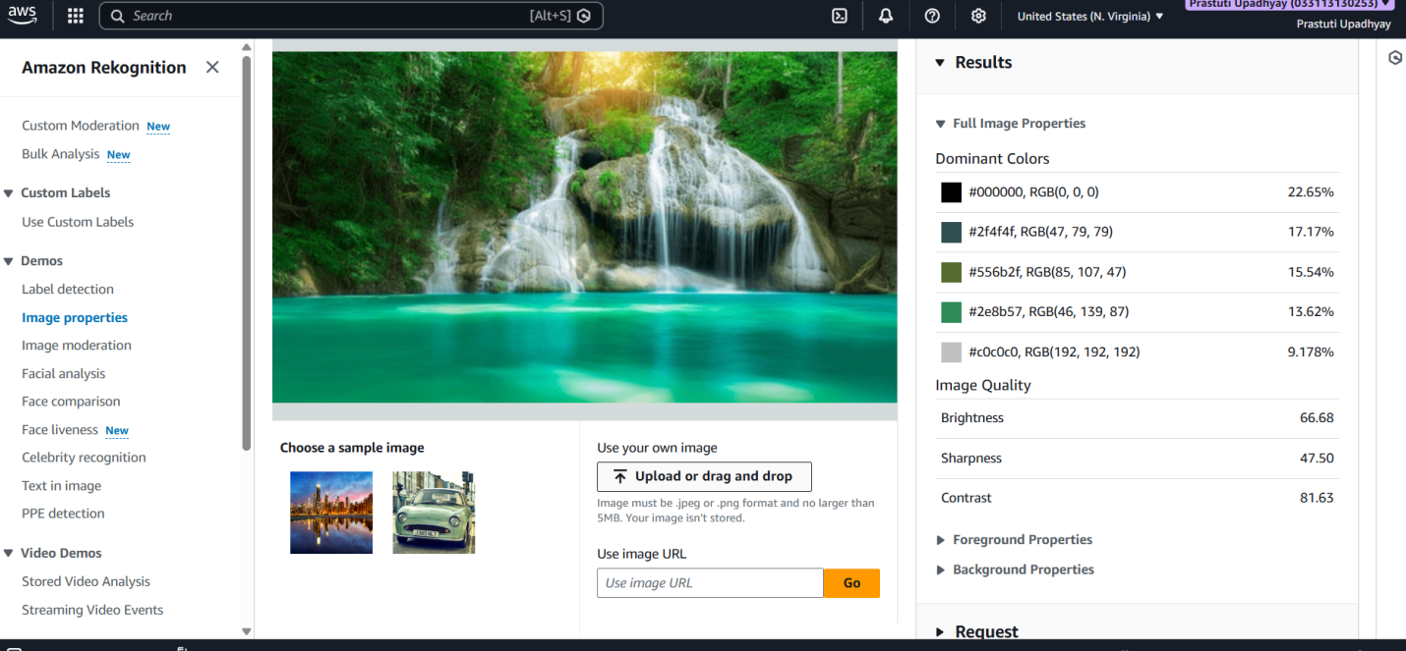
Image Moderation-
Image Moderation in Amazon Rekognition automatically detects unsafe or inappropriate content (such as explicit, violent, or offensive material) in images. It assigns moderation labels with confidence scores, helping applications filter and control content to ensure safety and compliance.
Example 1-
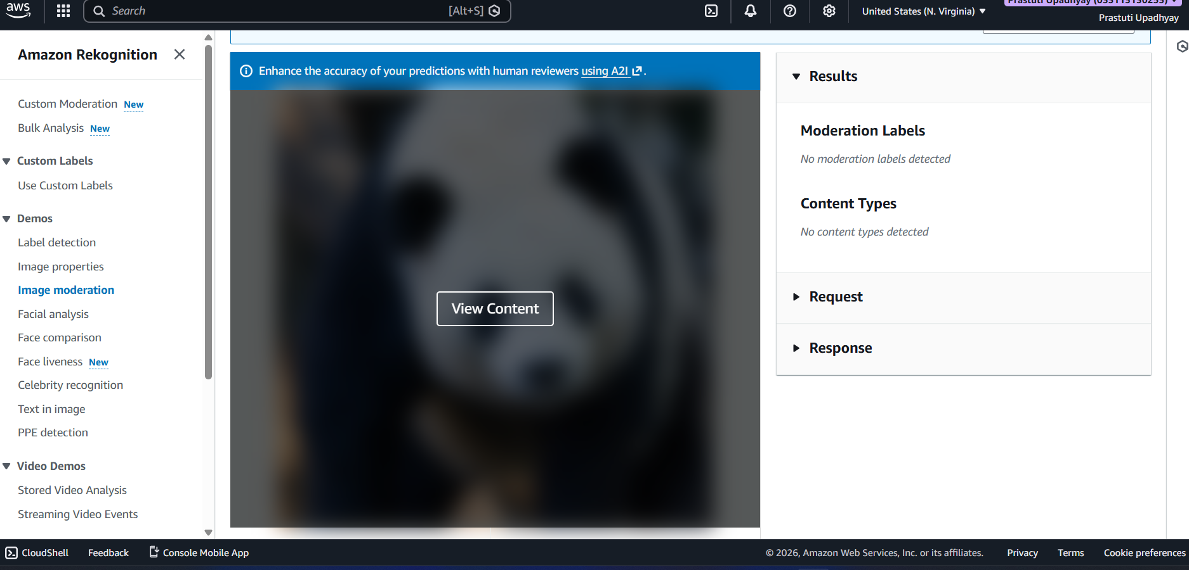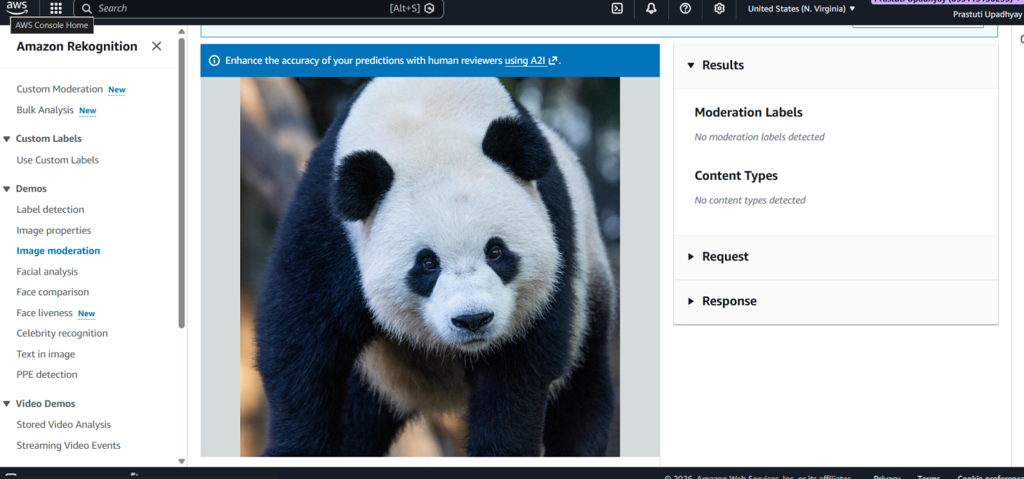
Example 2-

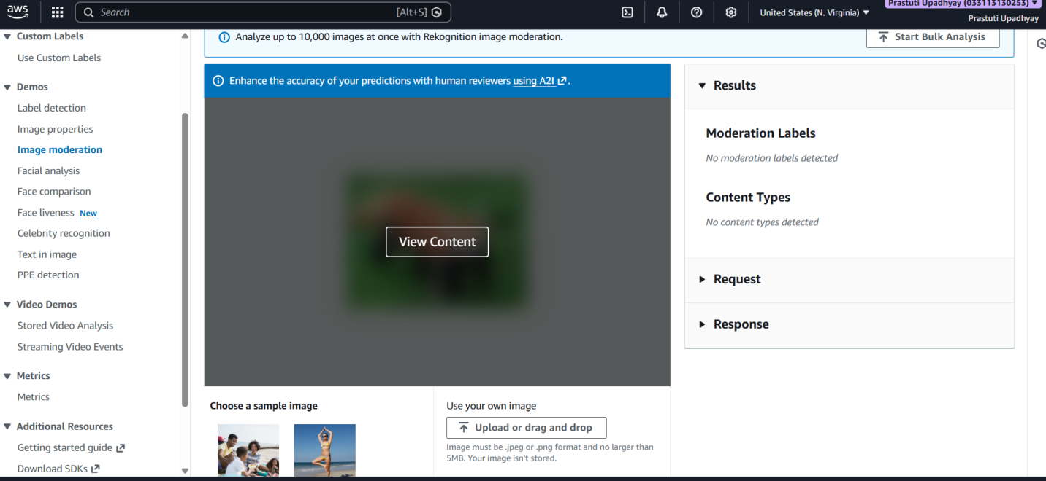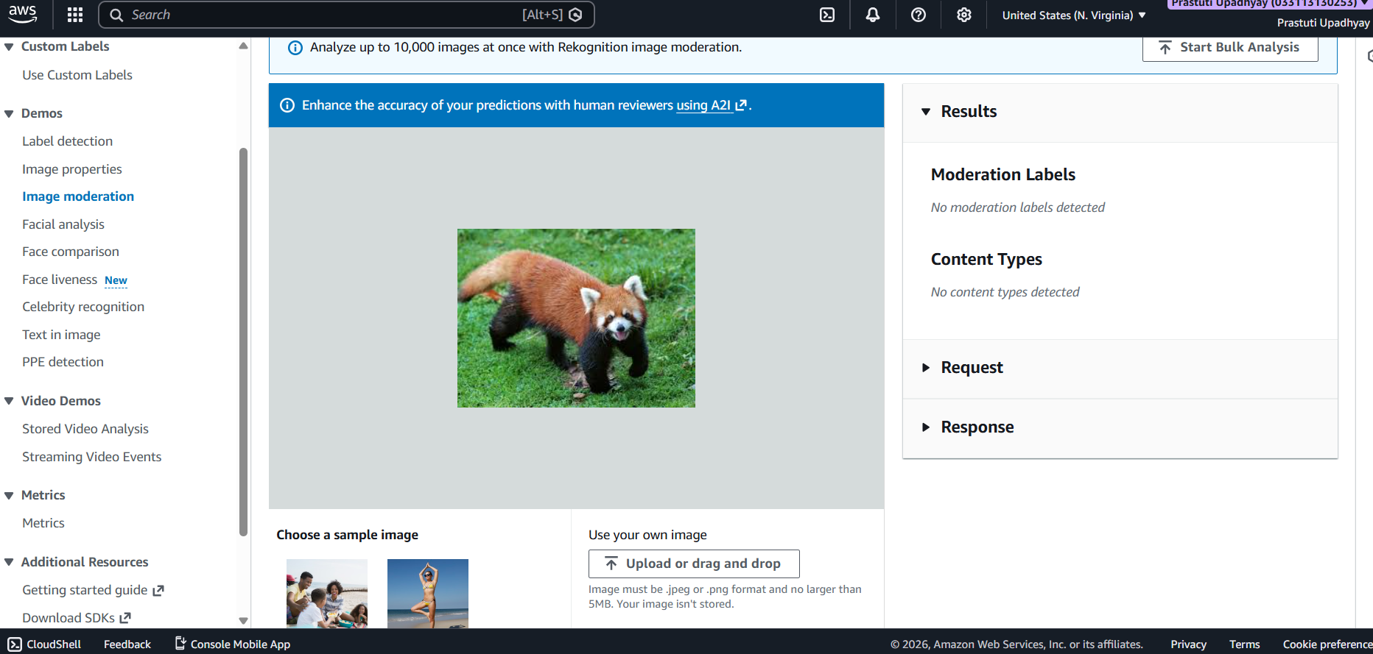
Facial Analysis-
Facial Analysis in Amazon Rekognition detects faces in images or videos and analyzes facial attributes such as age range, gender, emotions (happy, sad, angry), and facial features. It helps in applications like user insights, security, and behavior analysis.
Example 1-
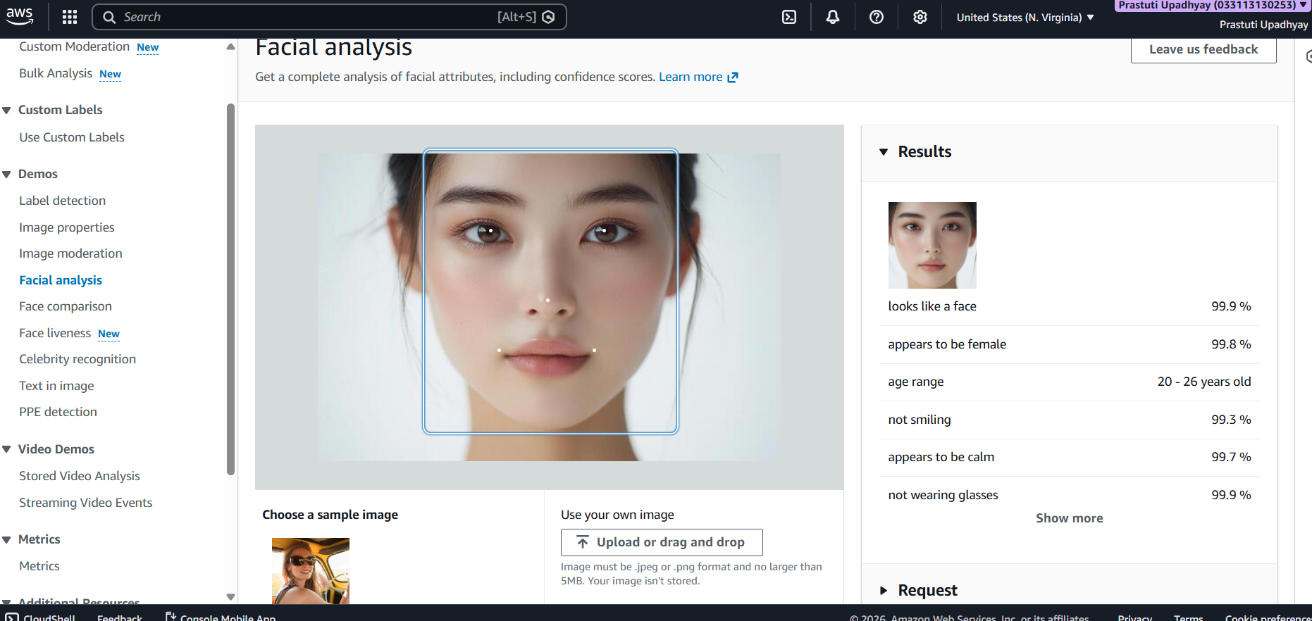
Example 2-
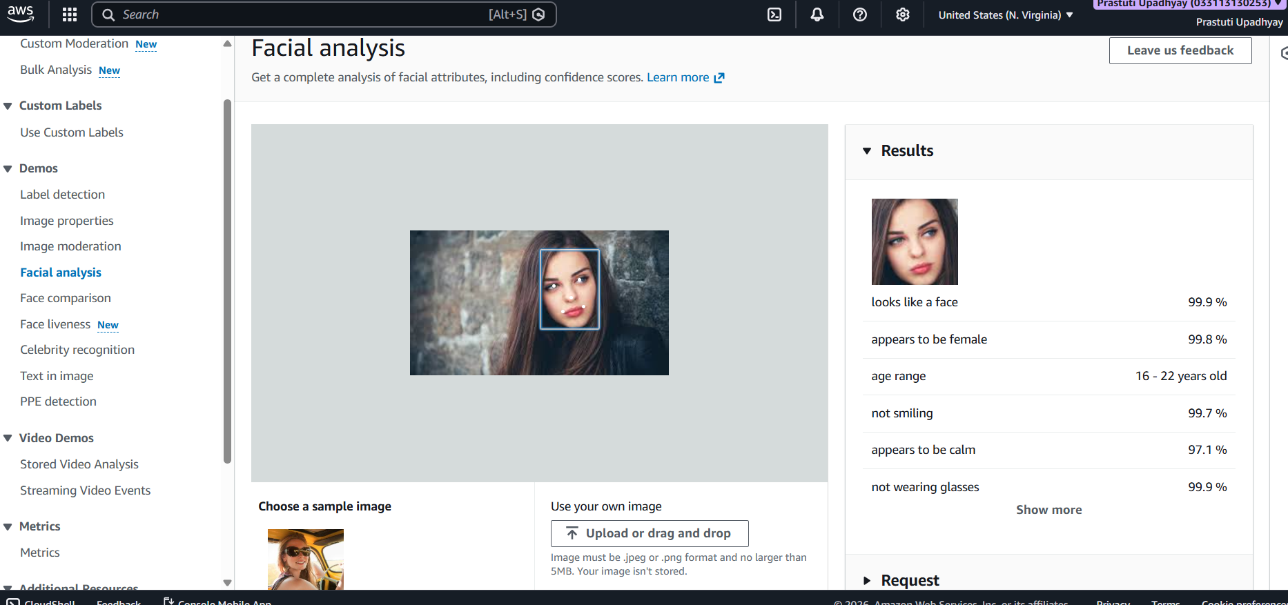
Face Comparison-
Face Comparison in Amazon Rekognition compares two faces to determine whether they belong to the same person. It provides a similarity score (%), helping in identity verification for applications like authentication, security checks, and access control.

Example 1-
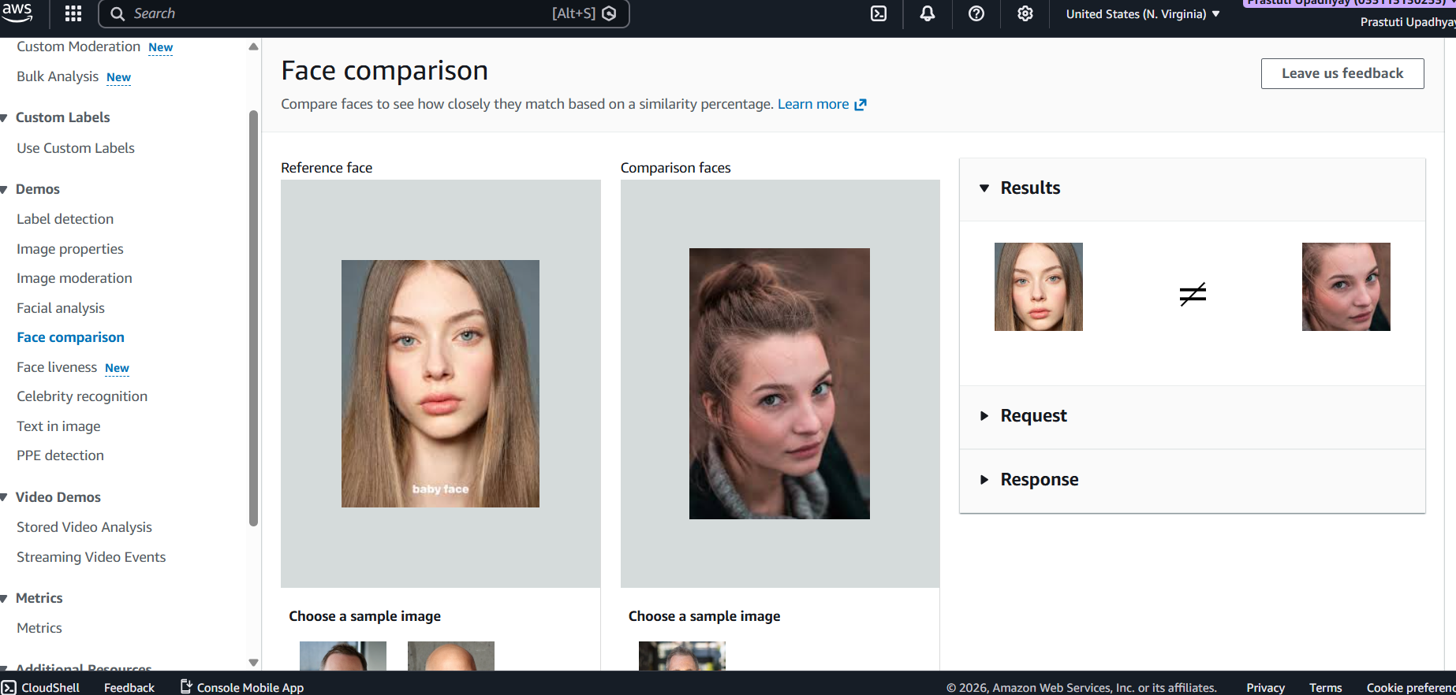
Example 2-
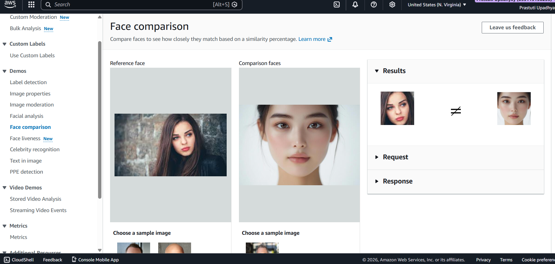
Face Liveness-
Face Liveness in Amazon Rekognition verifies that a face is from a real, live person and not a photo, video, or spoof. It helps prevent fraud by using real-time checks like movement and depth cues, making it useful for secure authentication and identity verification systems.
Example 1-
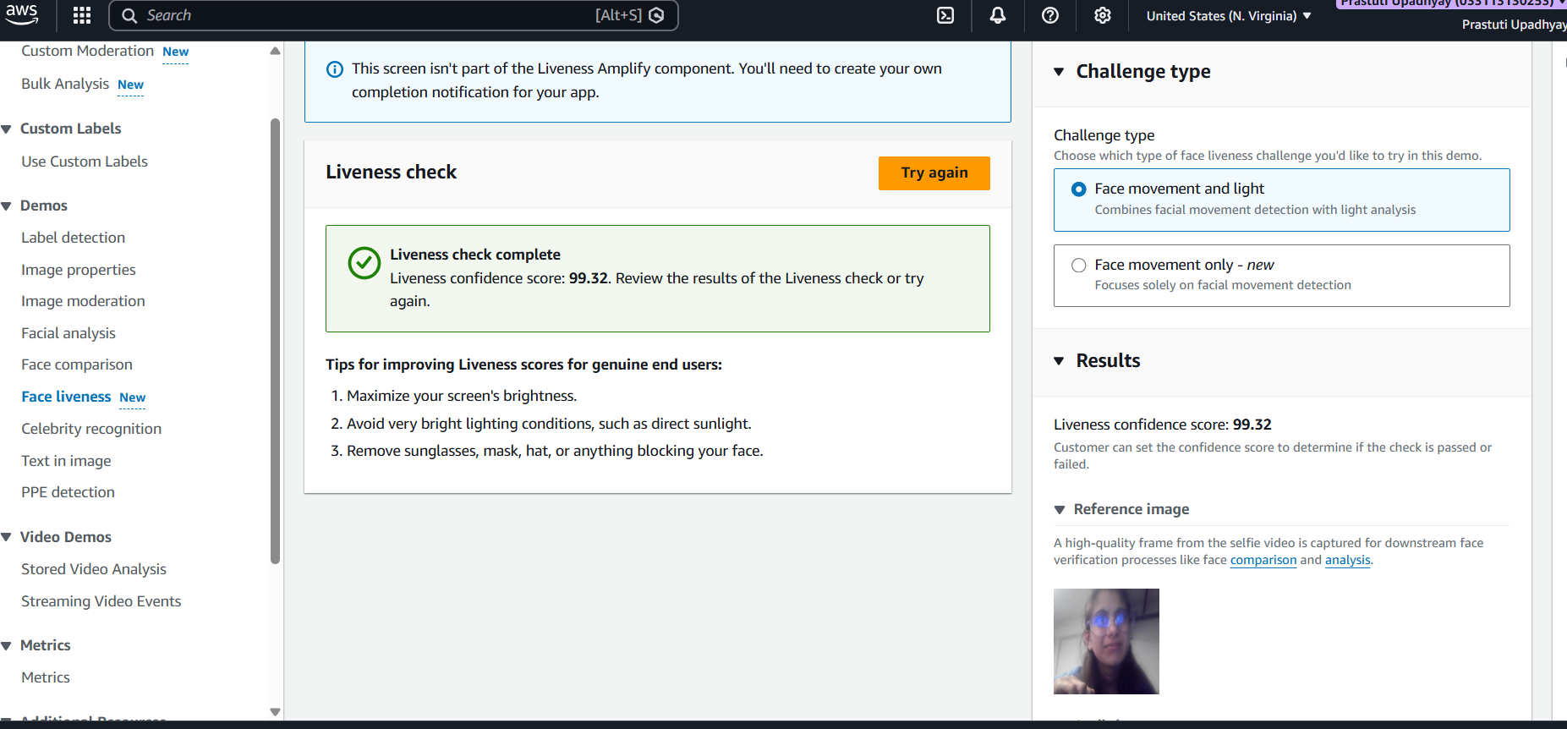
Example 2-
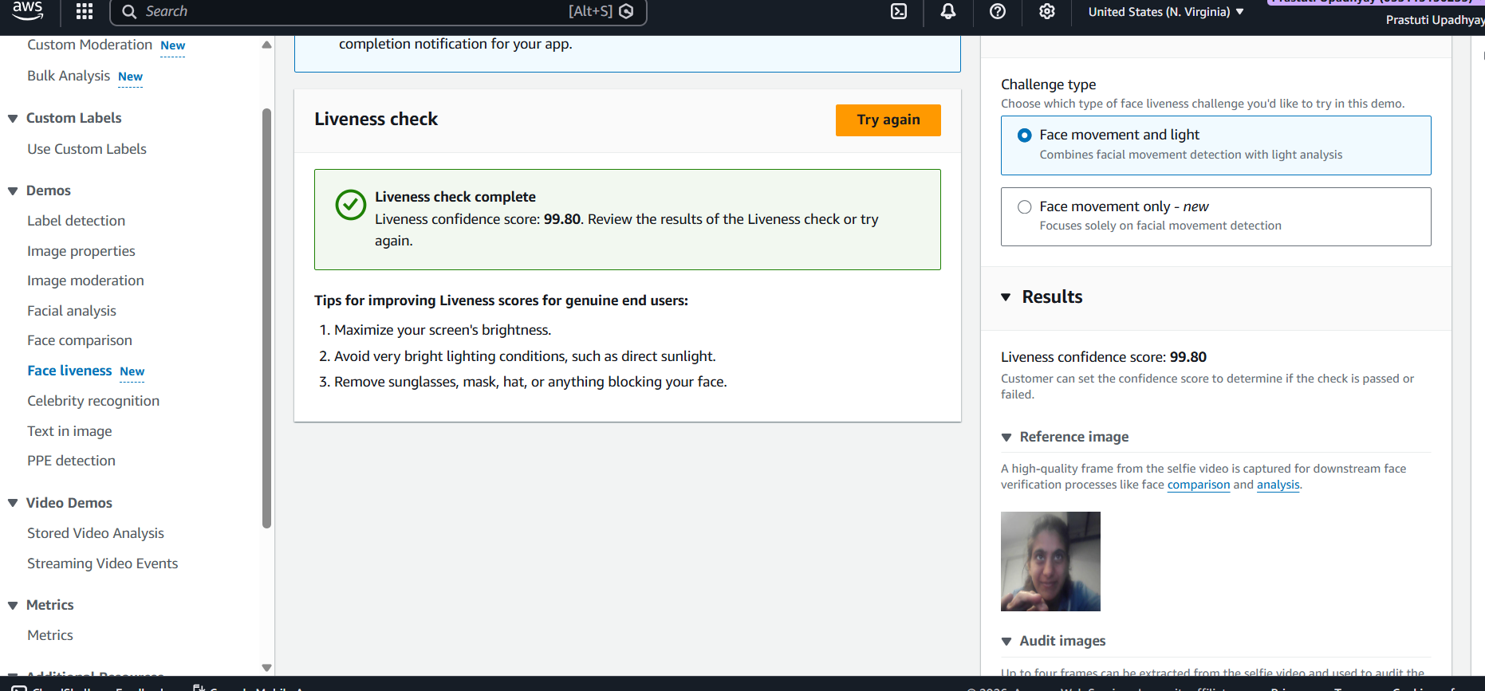
Celebrity Recognition-
Celebrity Recognition in Amazon Rekognition identifies well-known public figures in images or videos by matching faces with a predefined celebrity database. It returns the name and confidence score, making it useful for media tagging, content indexing, and entertainment applications.
Example 1-
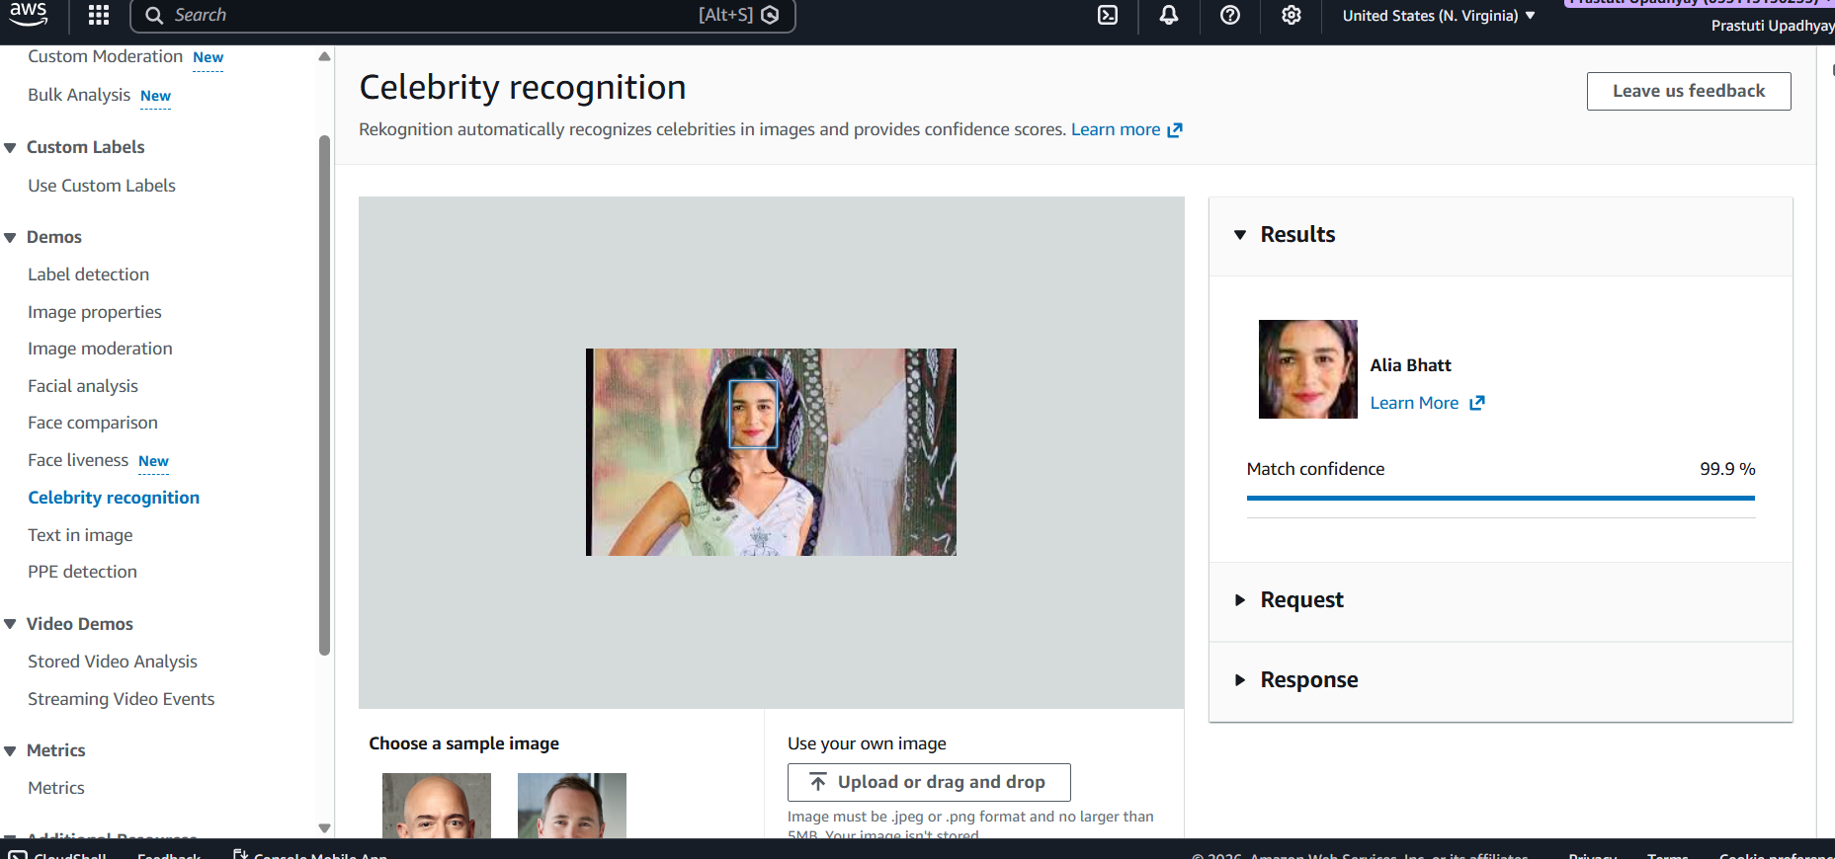
Example 2-
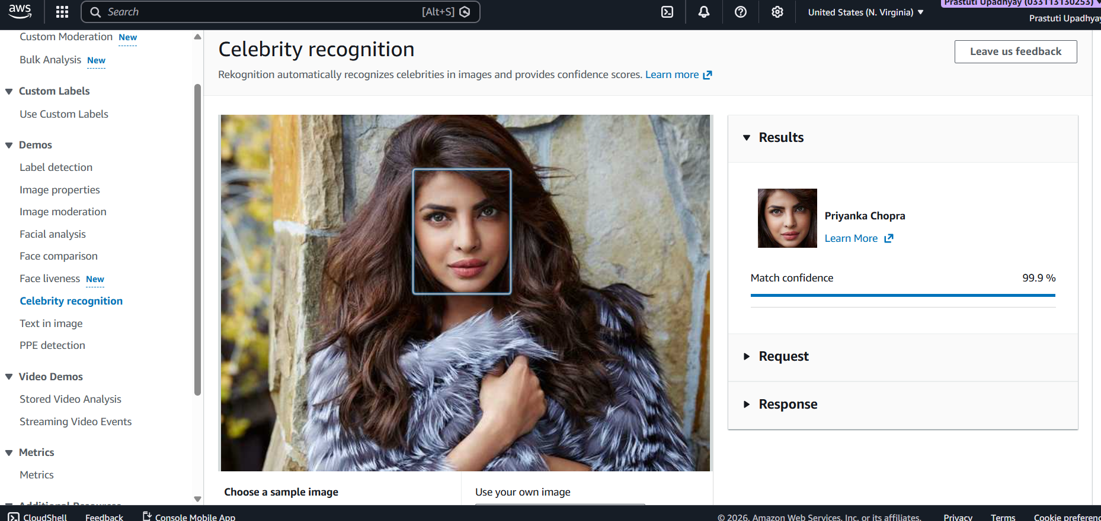
Text in Image-
Text in Image in Amazon Rekognition detects and extracts printed or handwritten text from images using OCR (Optical Character Recognition). It returns the recognized text with confidence scores, useful for applications like document processing, number plate recognition, and data extraction.
Example 1-
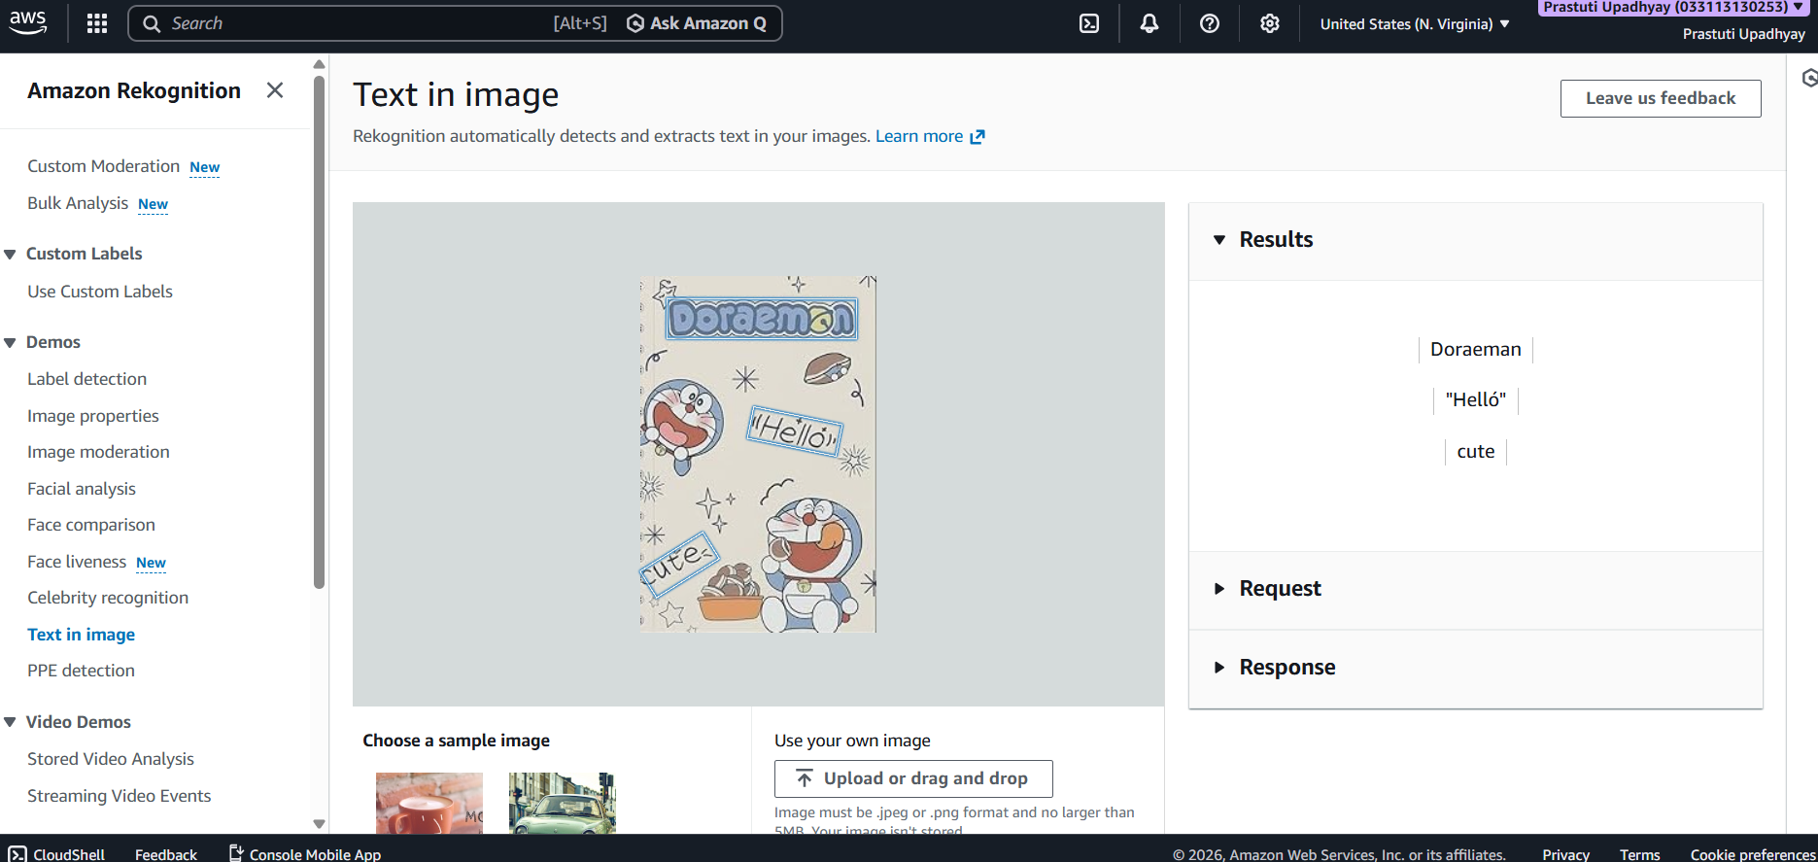
Example 2-
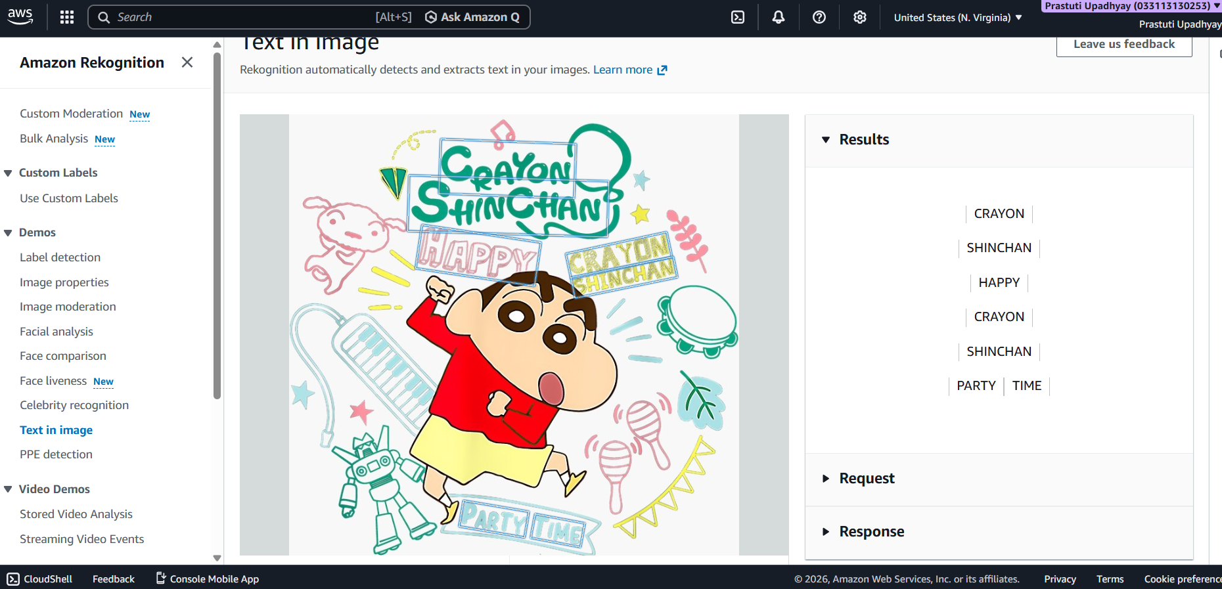
PPE Detection-
PPE Detection in Amazon Rekognition identifies whether people in images or videos are wearing personal protective equipment such as helmets, gloves, or safety vests. It helps ensure workplace safety compliance by detecting missing gear and providing alerts for risk prevention.

Example 1-
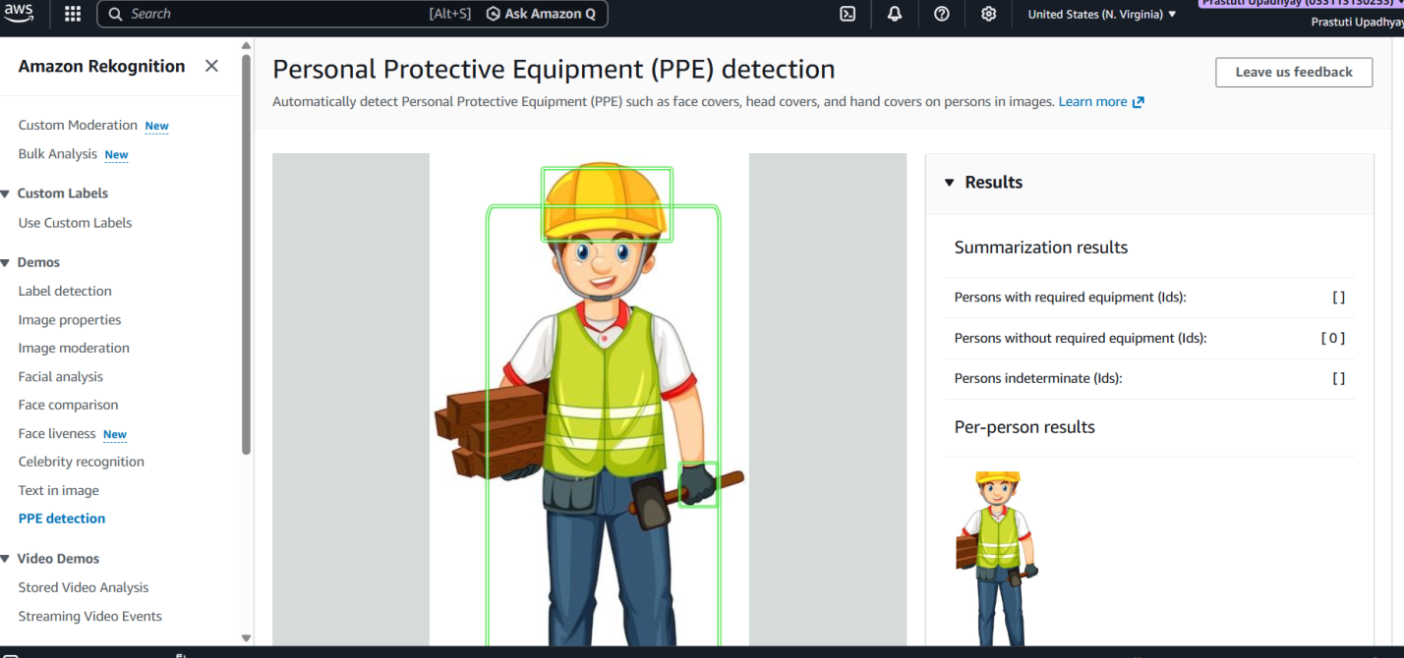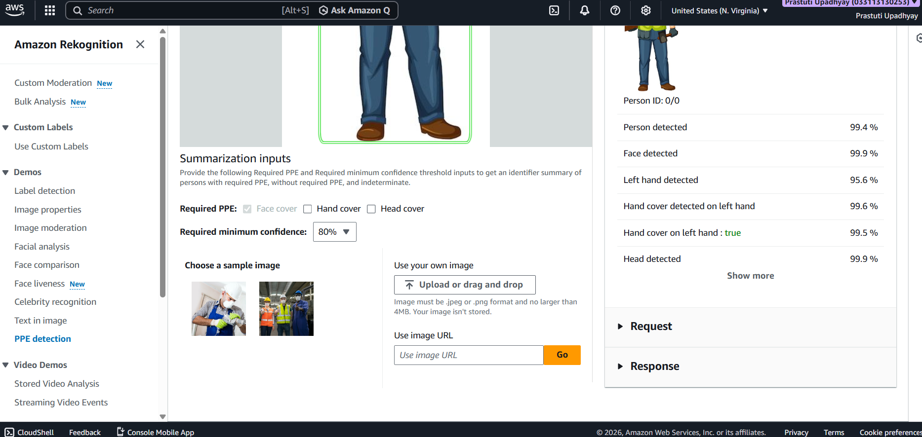
Example 2-
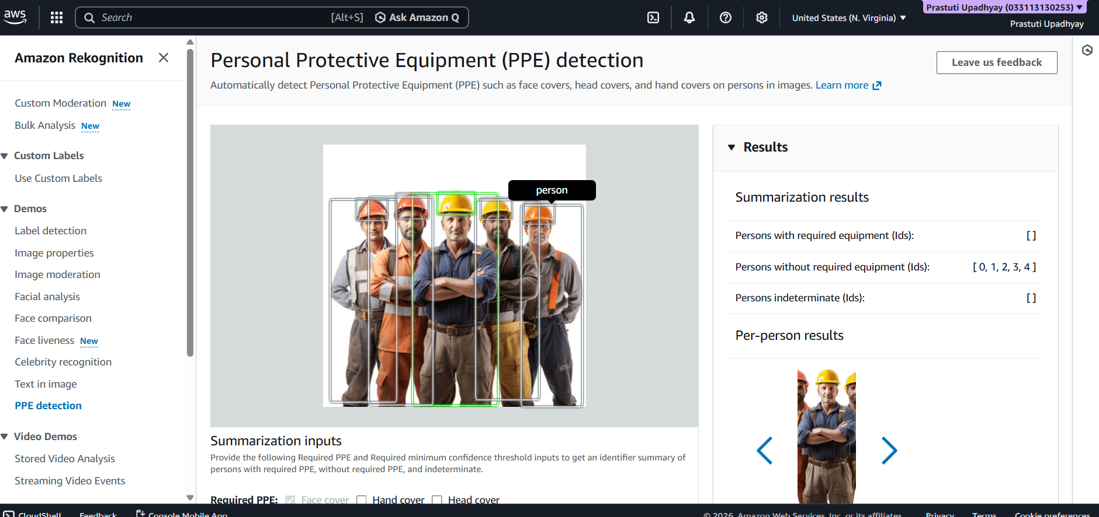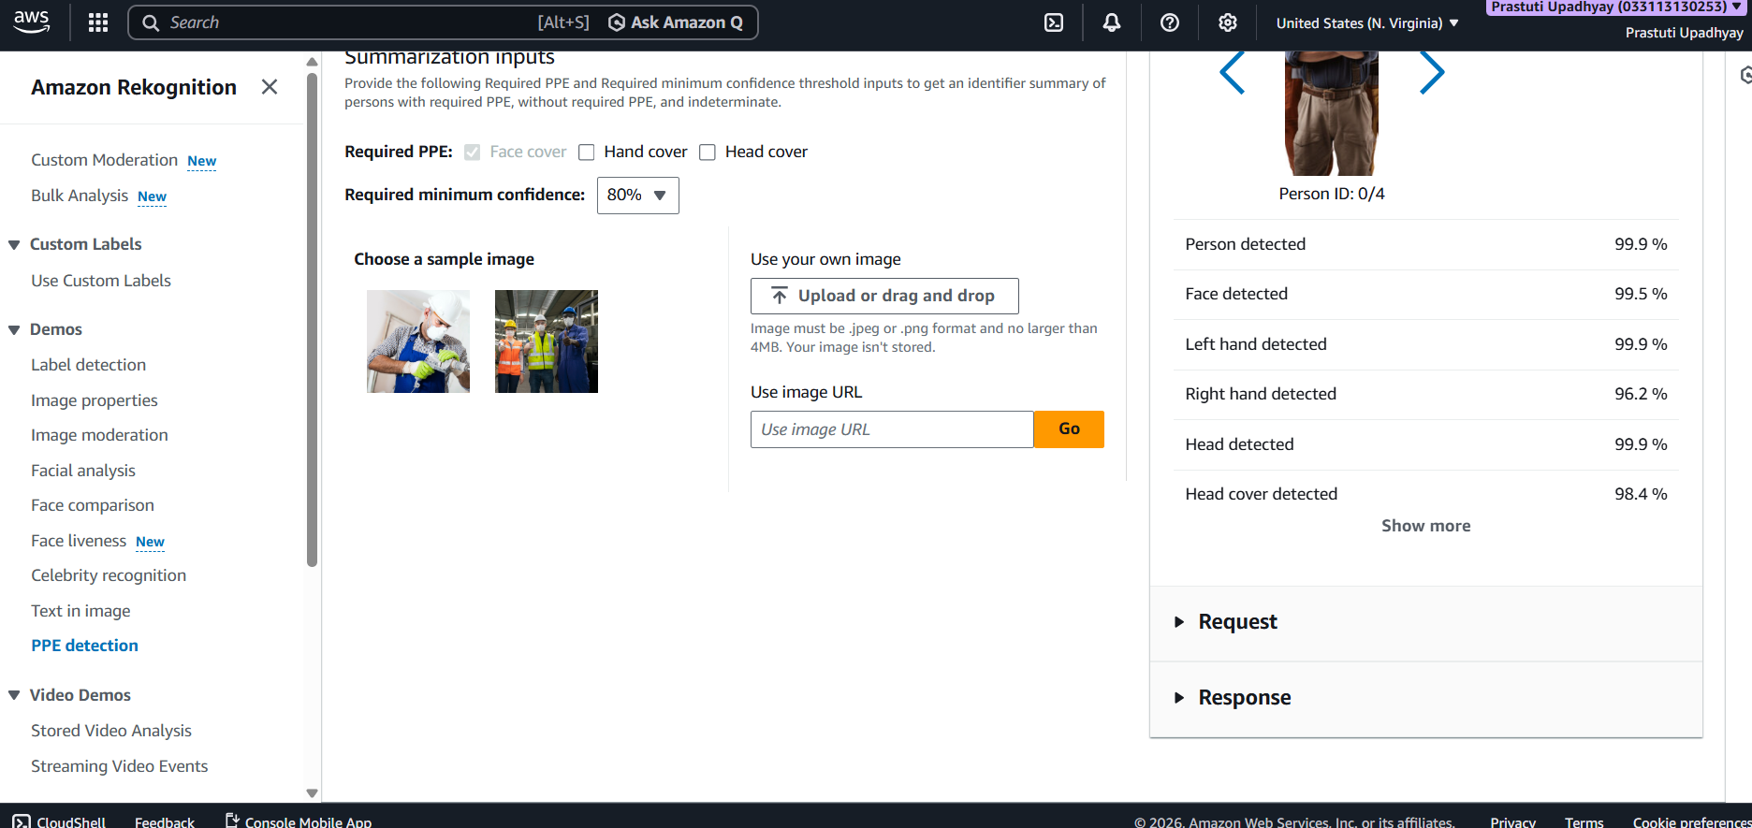
Video Demos-
Stored Video Analysis-
Stored Video Analysis in Amazon Rekognition processes pre-recorded videos to detect objects, faces, activities, and text. It analyzes video frame-by-frame and returns results with timestamps, helping in applications like surveillance review, content indexing, and event detection.
Example 1-
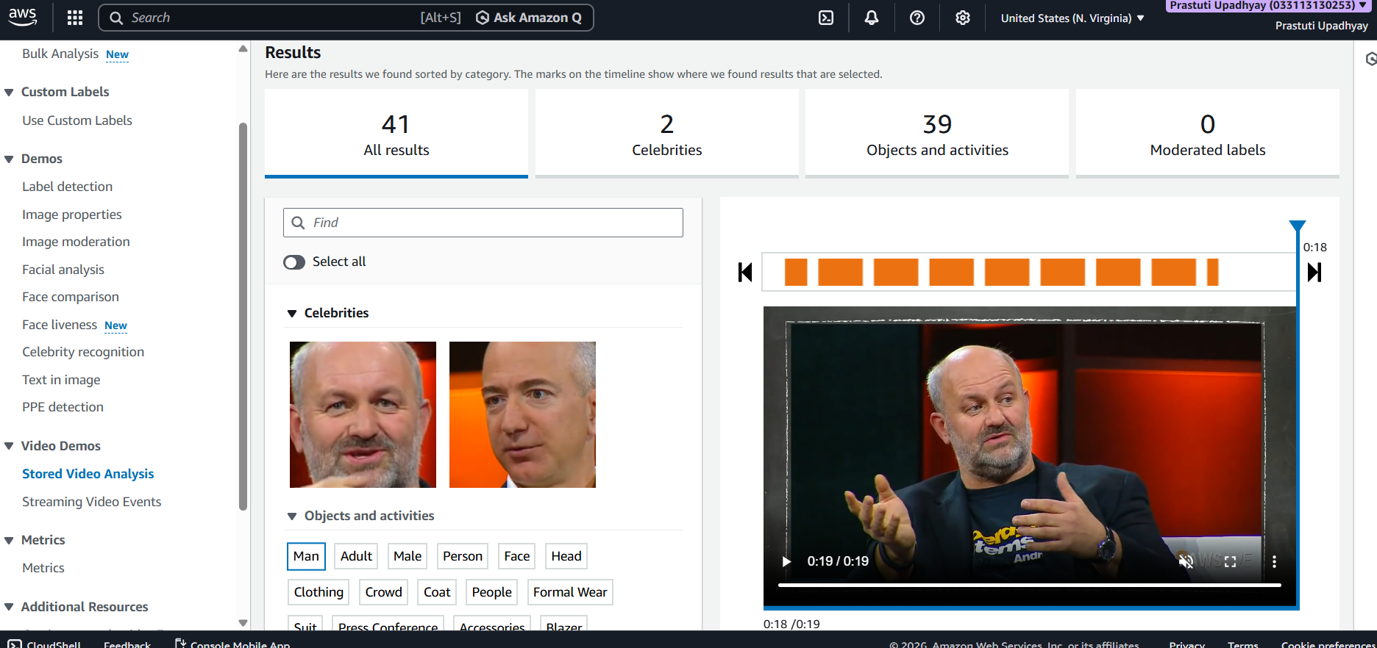
Streaming Video Events-
Streaming Video Events in Amazon Rekognition analyzes live video streams in real time to detect events such as faces, objects, activities, or unsafe situations. It provides instant alerts and insights, making it useful for surveillance, security monitoring, and real-time decision-making.
Example 1-
